Bamburi Sacco Member portal
User Manual

Login
- To login copy the link below on your browser
http://161.97.176.39:801/
- The screen below will appear
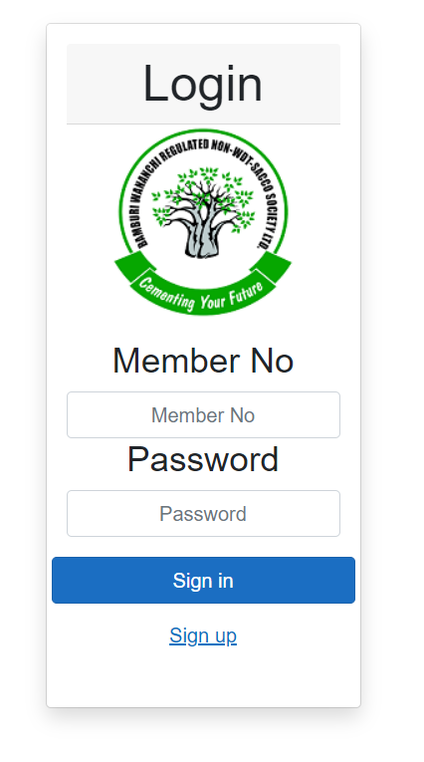
- First time login, click on Sign up. Screen below appears
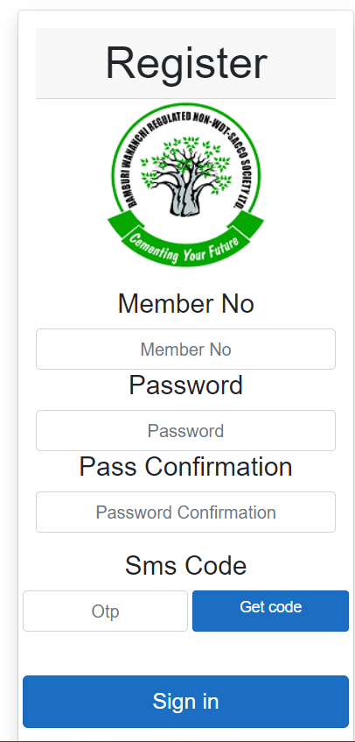
- Enter your member No
- Click on send Code
- A Otp will be sent to your phone number registered in the Core System.
  - If the number is different from your current, You will need to visit the sacco for phone number update.
- Enter the code sent
- Enter your preferred password
- Confirm your password
- Click on sign in

Dashboard
This shows:
- Your Loans, Deposit and Capital share balances
- A statement of your last transactions
  - This can be filtered by Date, Transaction Type, or Description
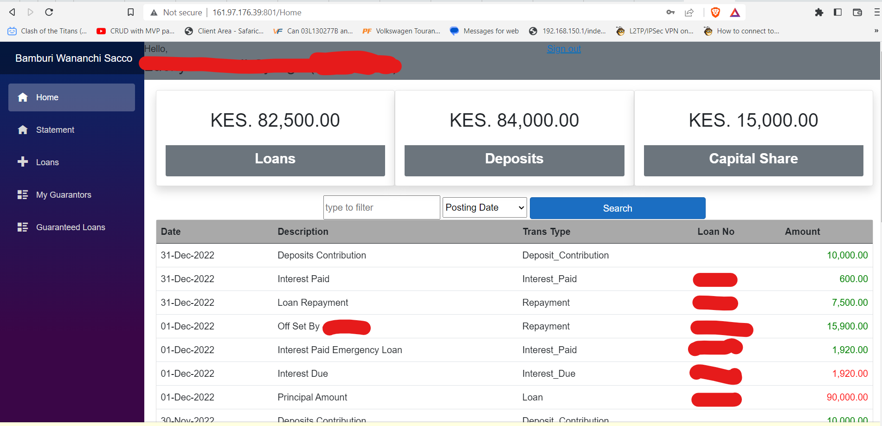

Statement
This will load a printable PDF statement of your account
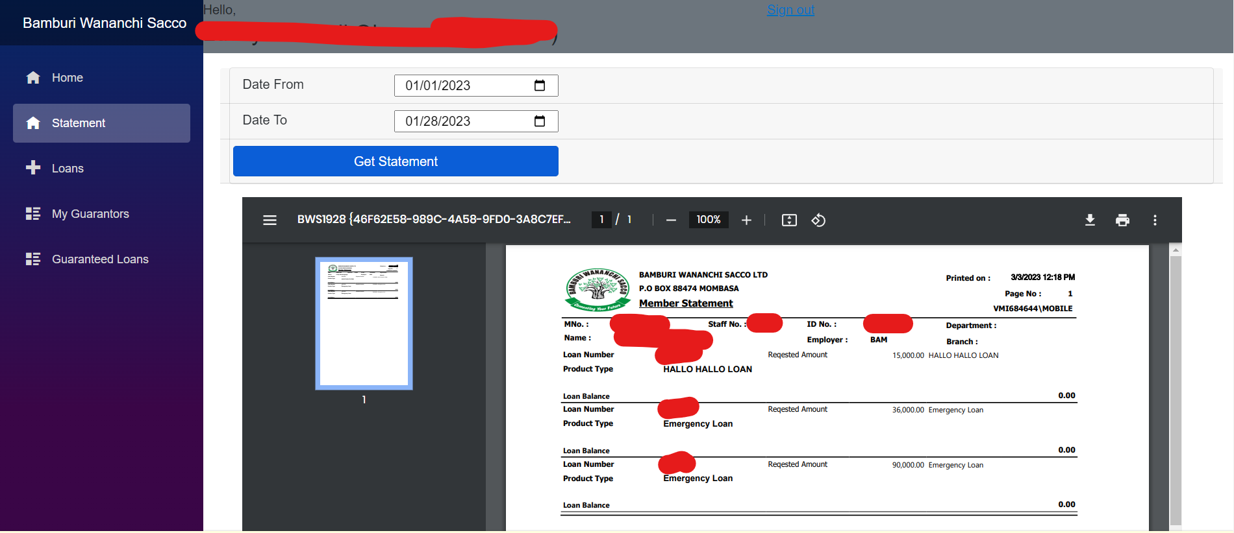

My Loans
Shows:
- A list of Your current Loans
- A list of your fully repaid loans
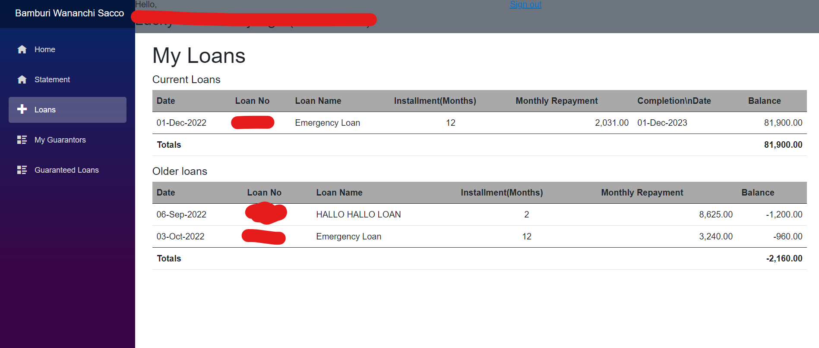

My guarantors
This will show a list of all Members who have guaranteed you in your loans.
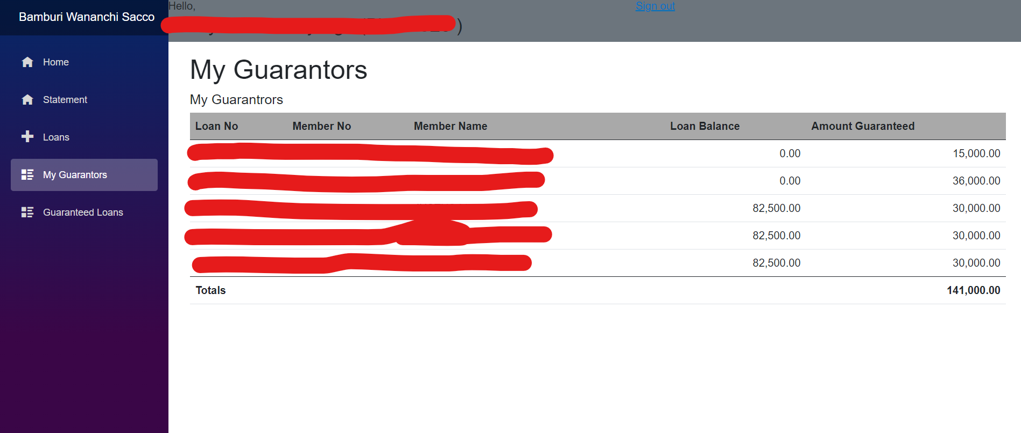

Loans Guaranteed
This will show you a list of loans you have guaranteed others and their current balances.
